Lab 8: Using Jasmin to run x86 Assembly Code
Course Name: Malware Analysis and Reverse Engineering (IAM302)
Student Name: Nguyễn Trần Vinh – SE160258
Instructor Name: Mai Hoàng Đỉnh
Lab Due Date: 15/2/2023

Purpose
To practice writing and running basic x86 assembly code, using the Jasmin interpreter

What You Need for This Project
- Any computer, running any OS

Install Java

Download Jasmin

Understanding the Jasmin Window
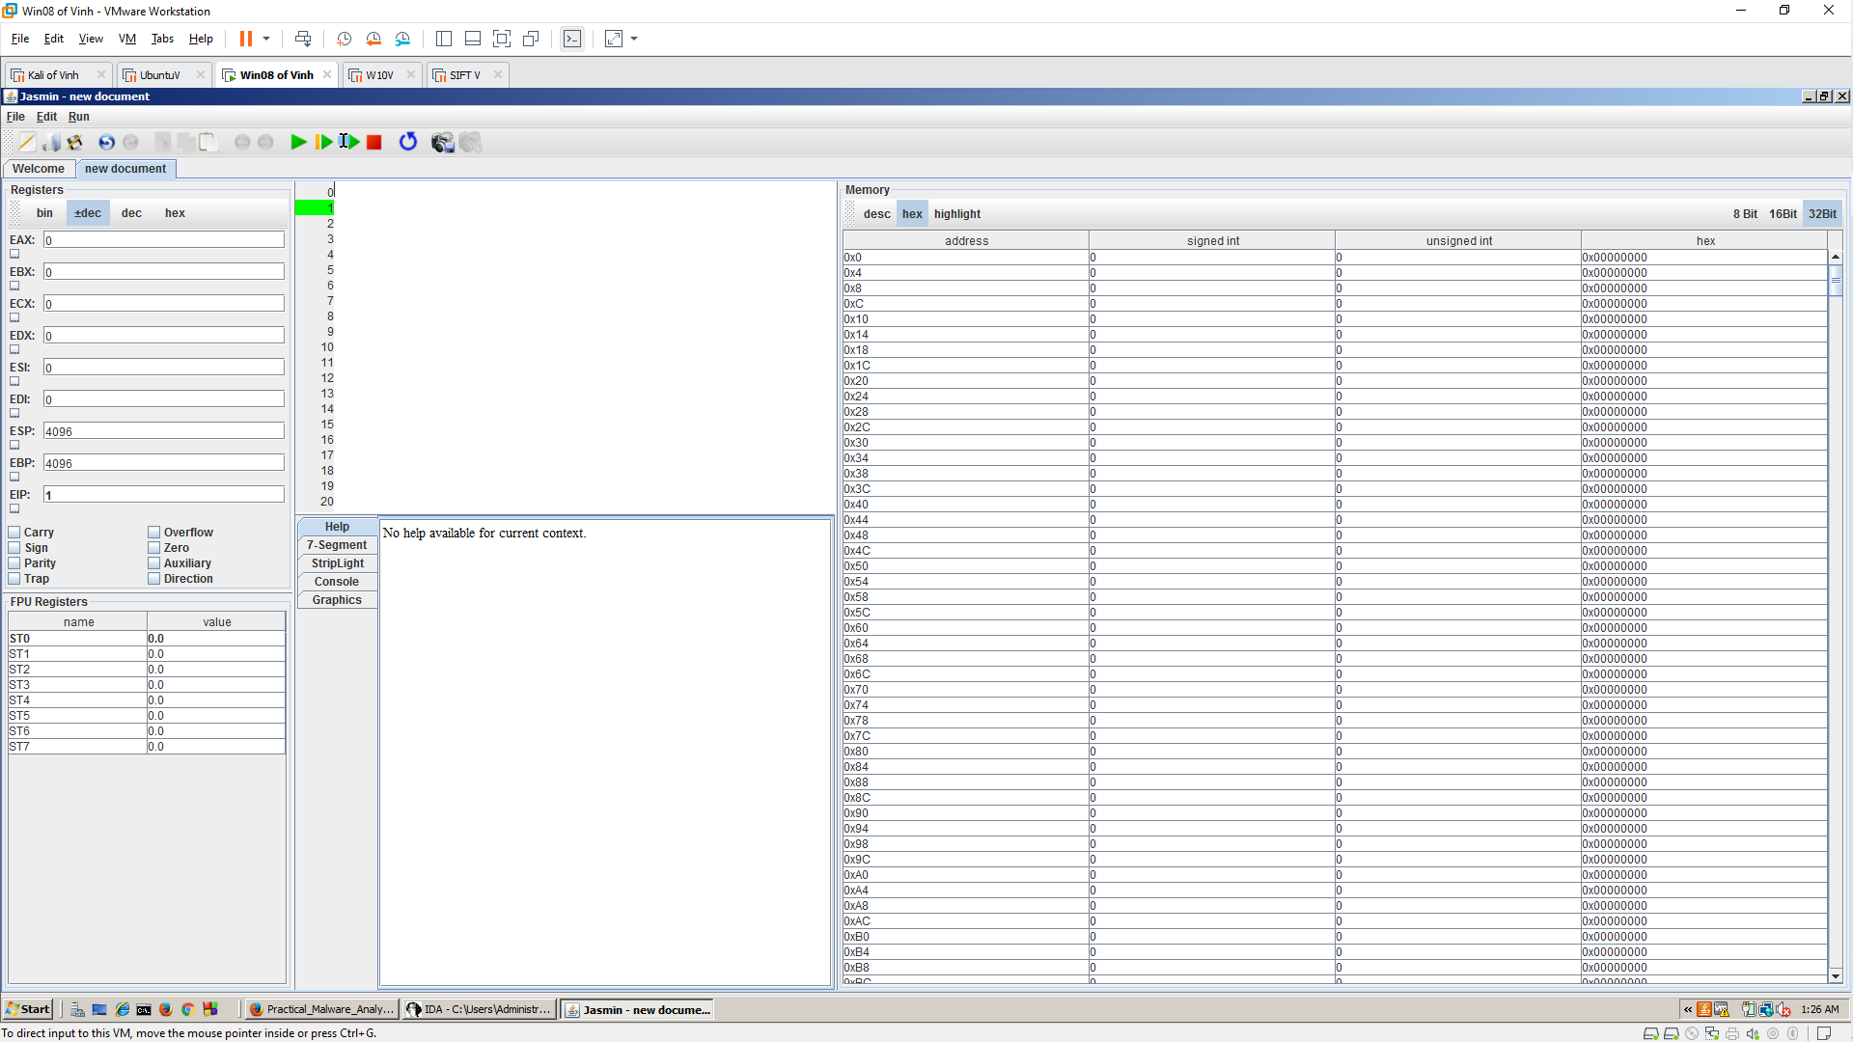

Registers
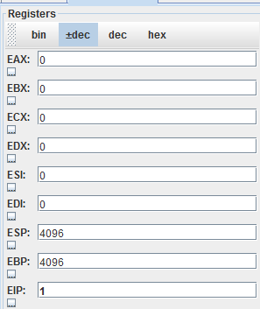

Flags
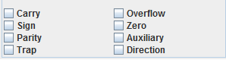

Code
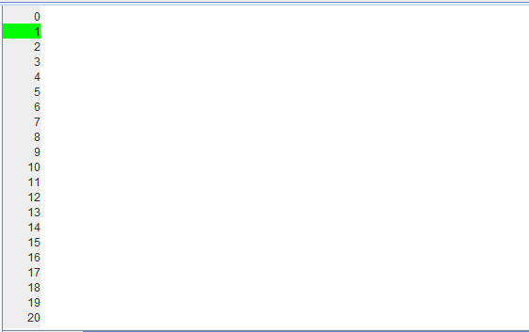

Help
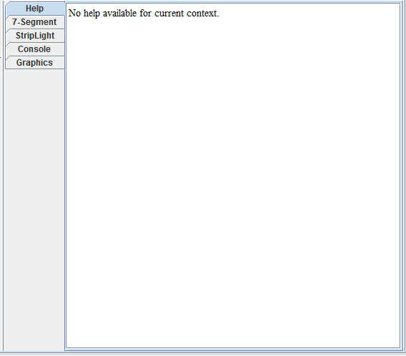

Memory
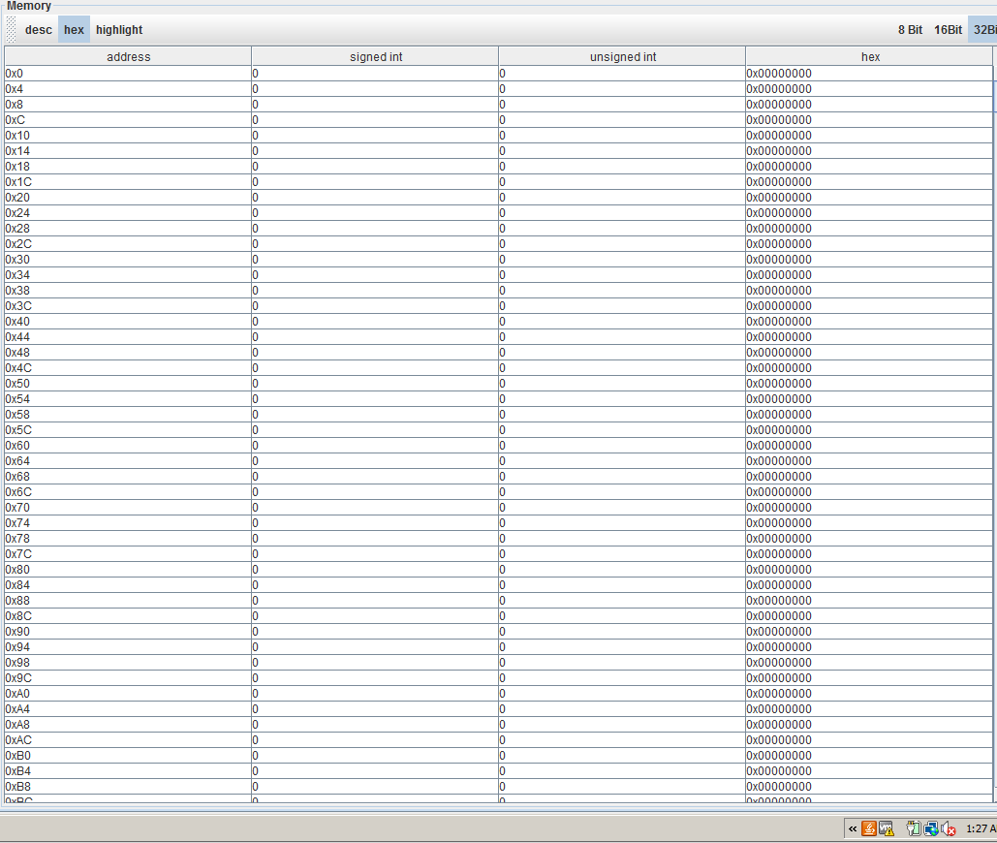

Using mov Instructions
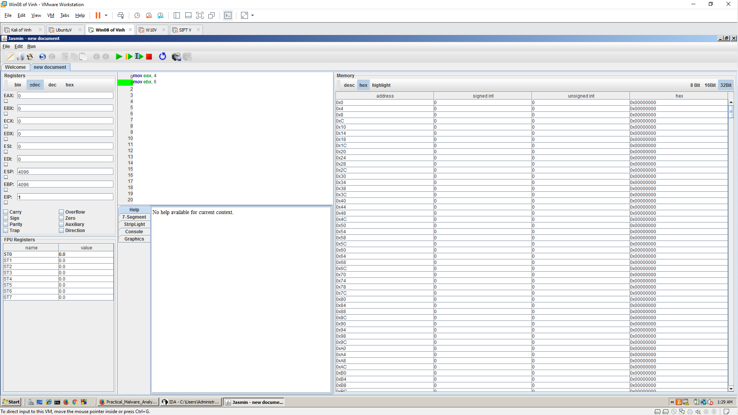
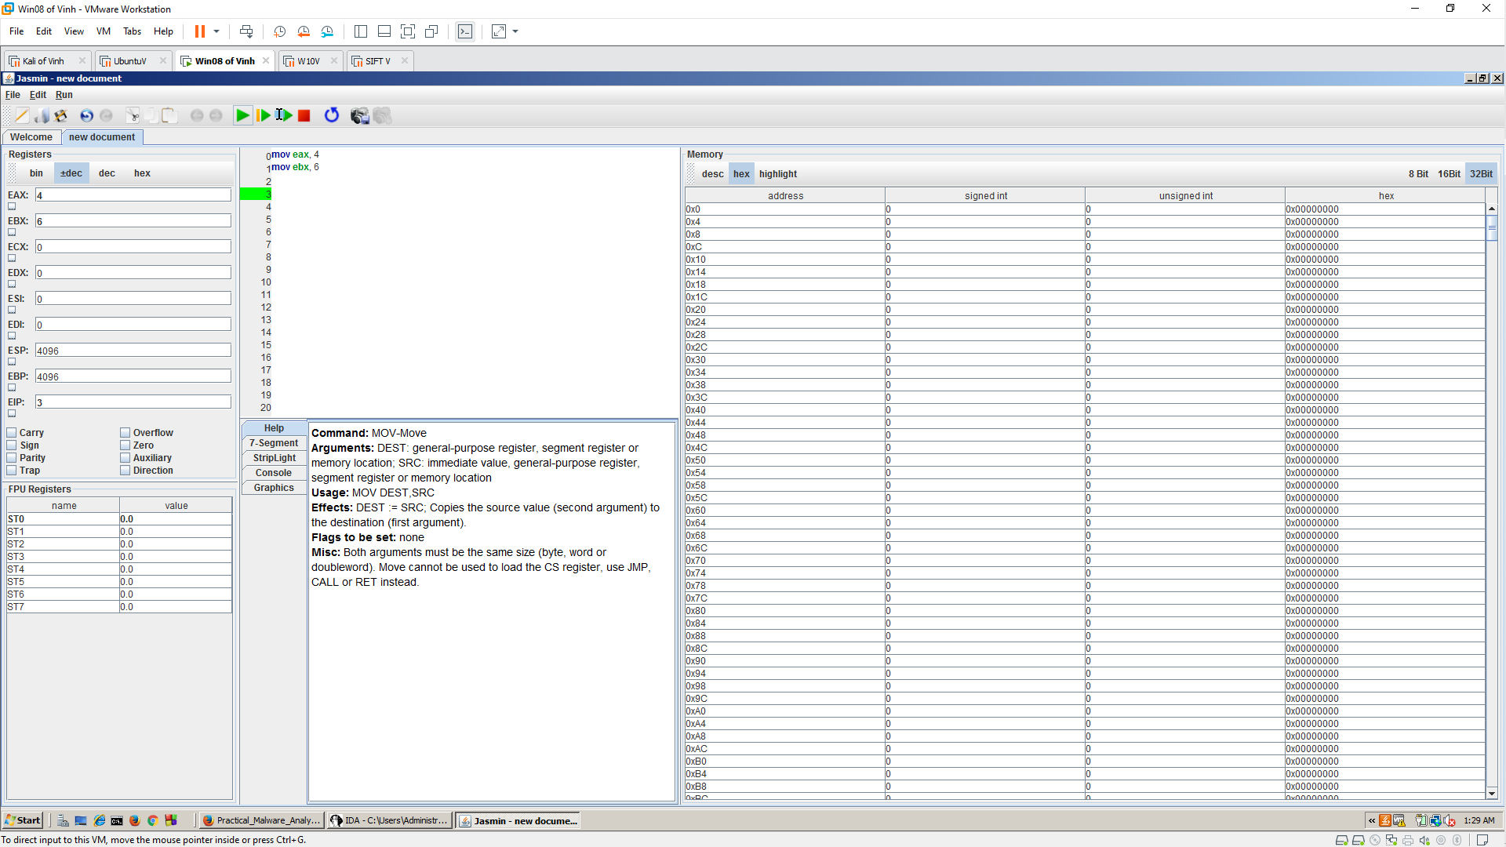

Storing Results in Memory
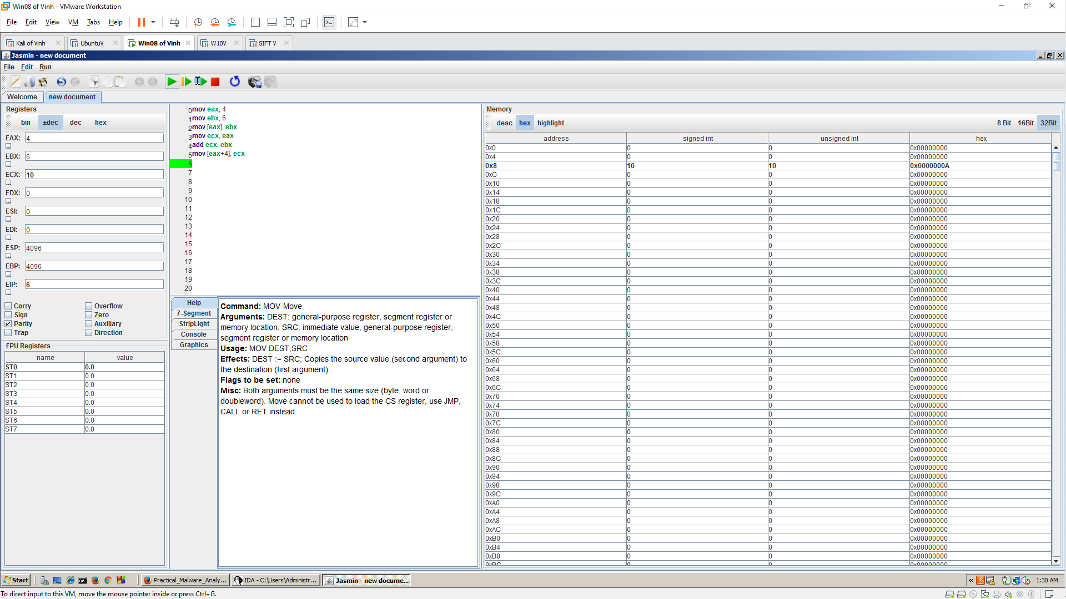

Using the Stack

Push
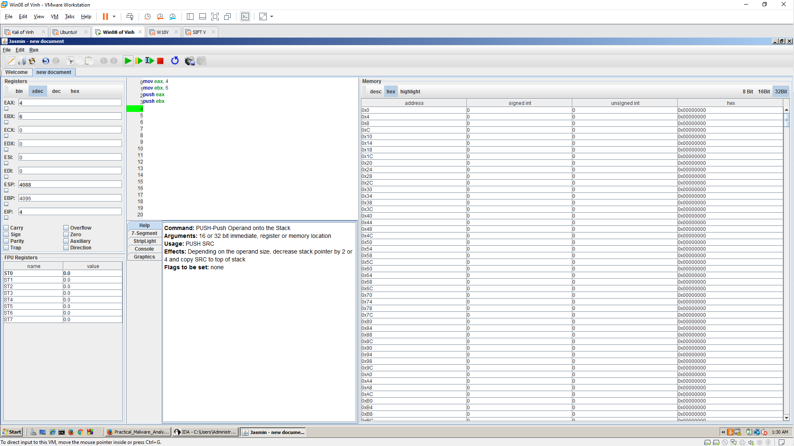

Pop
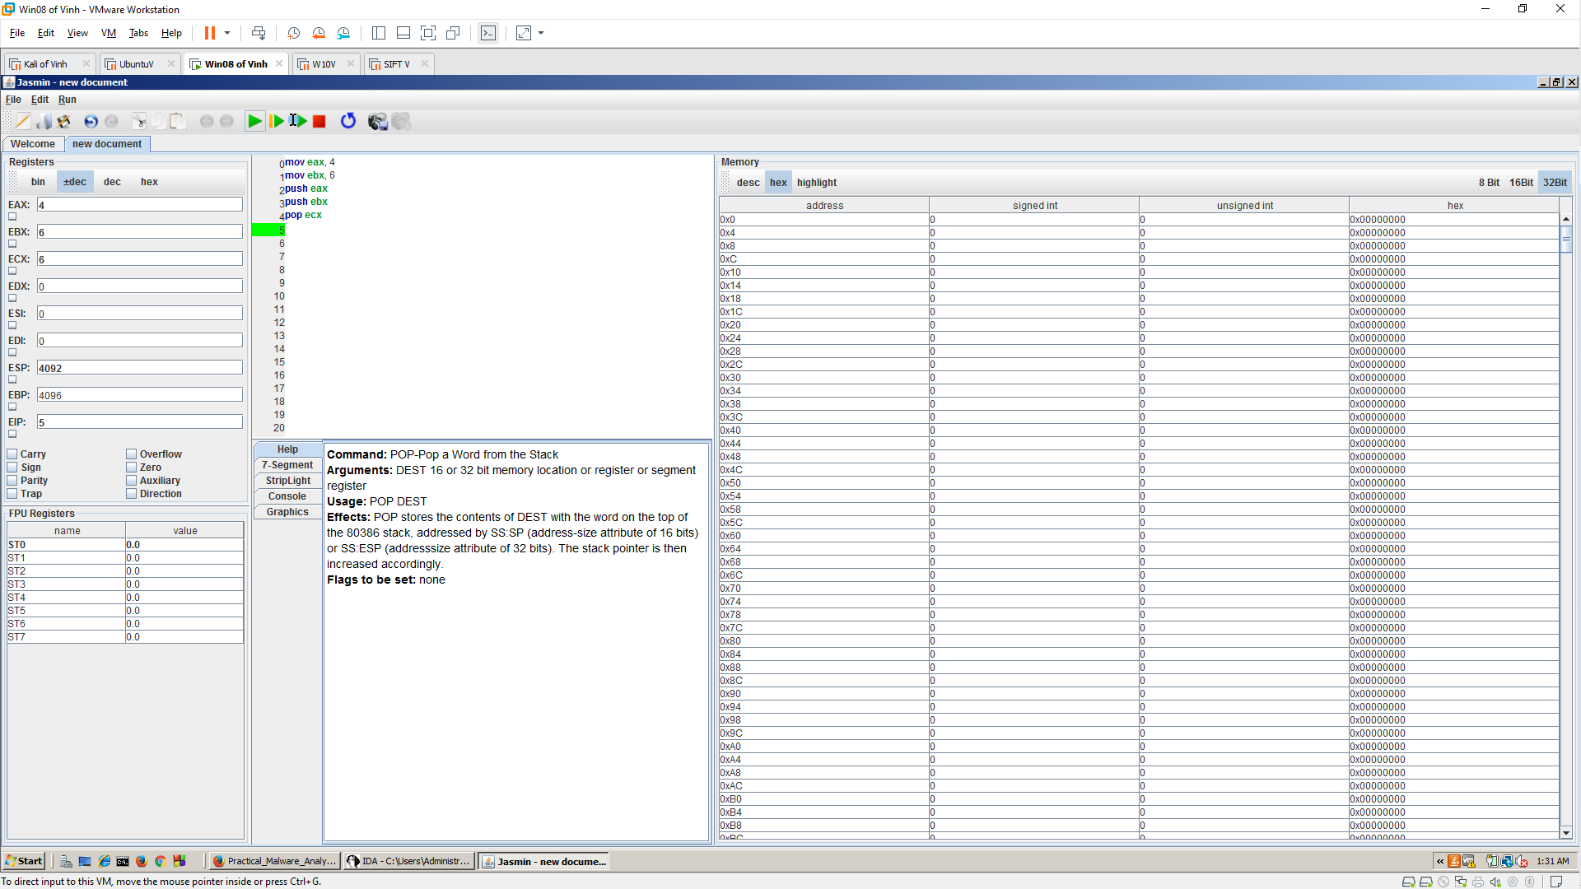

Reversing a Sequence
